MySqlWorkbench Tutorial:
How to Create Database Tables and Select Data

Contents

1. Overview 2
2. Before You Start 2
3. Review Database Terms and Concepts 2
4. Connect to MySql using MySqlWorkbench and Select Your Database Schema 4
5. Create Customer and Product Table, then Add Data 4
6. Add Data to Customer and Product Tables 7
7. Selecting Data 8
8. Where to Find Error Messages 9

Overview
After reviewing database terms, you will use MySqlWorkbench to create a database with 2 tables (customer and product) and enter test data into both of these tables. You will learn about primary keys (auto-increment and not auto-increment) and primary key constraints. You will also learn how to write and execute simple (single table) SQL select statements.

Before You Start
There is a separate document that tells you how to install MySqlWorkbench on your PC/MAC. MySqlWorkbench is a GUI (Graphical User Interface) front end to the MySql database management system (which runs on a temple database server). If you do not install MySqlWorkbench, you will have to use the CIS department lab computers to create your database and populate it with data. Later, when you are writing JSP code that accesses your database, MySqlWorkbench is also helpful – you can use it to see (select) the data from your database and provide helpful error messages for the SQL commands (e.g., select, insert, delete) that your java/JSP code will be using.

Review Database Terms and Concepts
- A table contains data about objects of a particular type or entity. Examples of entities are Customers, Products.
  - The rows in a table are called records.
  - The columns in a table are called fields or attributes.
  - Columns may have constraints. For example, when you define a column as being of data type “Date” (and it is a required field), this means that the database has a constraint that says, no record may be added unless it has a valid date in that field. If you specify another column as being 20 characters, the database will not allow a record to be added if it has more than 20 characters in that field.
  - Each table should have a primary key, which is one or more fields that uniquely identifies a record within the table. When you specify a primary key, you are setting up a constraint that says this table “shall not contain more than one record with the same primary key value as another record (in the same table)”.
  - A table may have zero or more foreign keys which “point to” another record (in the same or different table). When you specify a foreign key (with “integrity enforced”), you are setting up a constraint that says “no foreign key value can point to a non-existing record”.
- A database is a collection of related tables. When we design a database, we determine which tables need to be included for a given application, what fields or attributes are needed for each table, and how those tables should be related.
- A database management system (DBMS) is system software that encapsulates the database. There is no way to add, edit, delete, or even view the data unless you go through the database management system. You can think of the DBMS as the “bouncer” at a night club. Nobody unauthorized gets in. No actions (e.g., updates) are allowed if they would break the rules (constraints).

As we specify the field types and specific relationships between tables, this creates constraints to be enforced by the Data base management system (e.g., MSAcess). The DBMS ensures that
- only valid data goes in (e.g., valid dates in date fields, valid numbers in number fields),
- there are no duplicate primary key values in any table, and
- there are no invalid foreign key values (one record pointing to another record that does not exist).

The example below shows
- a database with two tables: an Employee table and a Department table.
- The Employee table contains 7 rows (also called records or objects), each representing a particular Employee.
- There are 8 columns in the Employee table (columns are also called fields or attributes) – so, that means we know 8 pieces of data (first name, last name, address, etc.) about each Employee in our table.
- In our example, Emp_ID has been specified as the primary key. Once a certain field (or fields) is specified as primary key, the DBMS will never allow two records with the same primary key value to be stored in a table.
- In our example, the Employee table has one foreign key field, Dept_ID that points to a record in the Department table. Once we tell the DBMS that a foreign key of one table points to the primary key of another table, the DBMS will ensure that there is never a pointer to nowhere.

Employee Table
Emp_ID | Last_name | First_name | Employee_Adrs | City | State | zip_Code | Dept_ID
1 | Paquette | Joe | 2224 Web Blvd | Centralia | WA | 99154 | 6
2 | Johnson | Fred | 410 Deer Ave | Centralia | WA | 99155 | 1
4 | Bradish | Emily | 512 Plaza Place | Seattle | WA | 99151 | 5
5 | Braak | John | 112 N Lincoln | Centralia | WA | 99154 | 6
6 | Shuster | George | 5003 Country Ln | Centralia | WA | 99155 | 1
7 | Tate | Frank | 603 Pinecrest Rd | Chehalis | WA | 99148 | 5

Department Table
Dept_ID | Dept_name | Dept_Expense_Act
1 | Marketing | 122897
2 | Sales | 453876
5 | Service | 677856
6 | Manufacturing | 187689

Given the above data (with primary keys and foreign keys specified), the DBMS will prevent the following actions.

- Cannot add this record into the Employee table (Duplicate Primary Key). Emp_Id = 7 is already there.
Emp_ID | Last_name | First_name | Employee_Adrs | City | State | zip_Code | Dept_ID
7 | Smith | Mary | 123 Any St | Chehalis | WA | 99148 | 5

- Cannot add this record into the Employee table (Invalid Foreign Key). There is no Department with Dept_Id = 888
Emp_ID | Last_name | First_name | Employee_Adrs | City | State | zip_Code | Dept_ID
8 | Smith | Mary | 123 Any St | Chehalis | WA | 99148 | 888

- Cannot delete (would create invalid foreign key for several Employee Records that have Dept_ID = 5)
Dept_ID | Dept_name | Dept_Expense_Act
5 | Service | 677856

Using a Database concept called “JOIN”, you can extract data that LOOKS redundant data (see below), but there is no actual redundancy within the database (no copies of data stored).
SELECT Last_name, First_Name, Employee_Adrs, Employee.Dept_Id, Dept_Name
FROM Employee, Department WHERE Employee.Dept_ID = Department.Dept_ID

Last_name | First_name | Employee_Adrs | Dept_ID | Dept_Name
Paquette | Joe | 2224 Web Blvd | 6 | Manufacturing
Johnson | Fred | 410 Deer Ave | 1 | Marketing
Bradish | Emily | 512 Plaza Place | 5 | Seattle
Braak | John | 112 N Lincoln | 6 | Manufacturing
Shuster | George | 5003 Country Ln | 1 | Marketing
Tate | Frank | 603 Pinecrest Rd | 5 | Chehalis

Connect to MySql using MySqlWorkbench and Select Your Database Schema
There is a separate document that tells you how to find your database credentials and connect to the database that was created for your use in your class. It’s a little involved the first time since you have to find your database password, etc.

Create Customer and Product Table, then Add Data
Using MySqlWorkbench, locate then open up your database (left pane under “SCHEMAS”). To create a table, right click on “Tables” (under your database schema), then select “create table”.
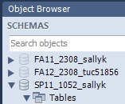

From the “New Table” window, enter the table name (“customer”), select the proper database engine “InnoDB” (or else foreign keys will not work), and get ready to enter in the columns that you would like for your customer table.
Click here if you can’t see the columns area.
Enter “customer” as table name here.

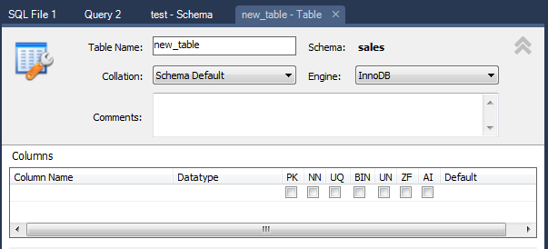
Select “InnoDB” since that supports foreign keys (which we need).
Mouse over the abbreviations above the check boxes so you can understand what’s involved in designing a database table.
- PK: Primary Key (unique identifier of each record within the table)
- NN: Not Null (not allowed to be null, means it is a required field for the user to enter)
- UQ: field must be unique within the table.
- AI: Auto-increment. The database management system supplies the next available number (automatically) – the user does not have to enter a value into this field.

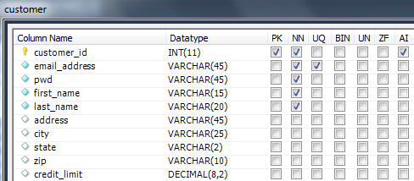

When you design a database table, create all of the columns that you want in your database table.
- Typically you will have one column that is the primary key (PK, NN). This column is usually also an auto-increment (AI). By naming convention, the name of this field should be tableName_id. In this tutorial, one of the tables (customer) has an auto-increment primary key, but the other (product) does not. This is to show you the difference between the two typical design choices.
- For other columns, specify the desired data type. Here are some of the “normal” types are:
  - VARCHAR: specify the maximum size of a string to be stored.
  - INT: this is a normal integer. Specify the maximum number of digits to be stored.
  - DECIMAL: this is the best data type to store currency. It’s stored like an integer (not real number/floating point number), but with the decimal point moved to the left a certain number of digits. Specify the maximum digits and the number of digits to the right of the decimal point.
  - DATE: this is the data type to use (not DATETIME) if you just want to store day/month/year. DATETIME Is more complicated to use – it includes hours/minutes/seconds/milliseconds and it requires more effort to convert and format.

Create another new table named “product” and enter the columns and data types as shown below.
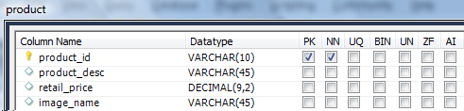
You should be able to see the two new tables you just created (as shown). If you do not see them, right click on “tables” and select “refresh”.
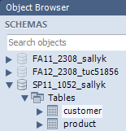
If you need to modify the design of one of your tables, right click on the table, then select “alter table”.

Add Data to Customer and Product Tables
- To add data into the customer table, right click that table and select the top option “Select Rows”. Remember that you specified the customer_id as an “auto-increment” Primary Key which means MySql will assign values so don’t enter values into the customer_id column.
- Enter just one row, then apply your changes (either an “apply” button or a green checkmark about the data entry area). If you made any mistakes (e.g., entered more characters than the field), the DBMS will reject your data.
- Then enter several (3-5) more rows of data into your customer table.
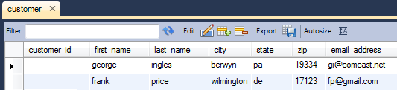

- Likewise add 3-5 rows of data into your product table, but remember that the product_id Primary Key was NOT set an auto-increment, so you have to type in values that are unique into this field. Try adding a duplicate primary key and see what kind of error you get.

Selecting Data
To extract data from the database use the SQL SELECT statement.
- Type your SQL into the window as shown, then click on “Query – Execute” or click on the lightning bolt icon.
  - The first statement (USE) specifies which database schema we are using. If you have selected your schema from the “default database schema” pick list, you do not need to enter the USE statement.
  - The second statement (SELECT) indicates that we want to see all the columns (*) from the product table. Since no WHERE clause is used, all records are shown.

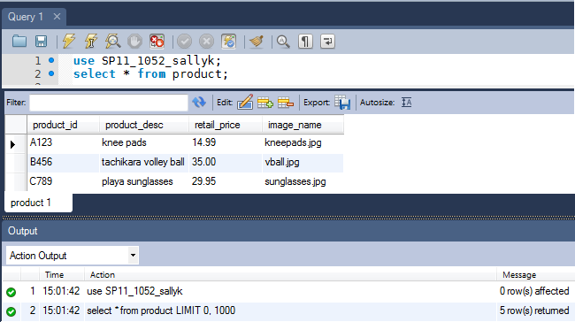
Note: if you have a lot of SQL in the “Query window” and you only want to execute part of it, you can highlight the part you want to run before clicking the execute icon (lightning bolt).

You can specify which records you want to see by adding a WHERE clause.
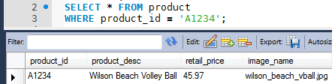
You can split a SQL statement into multiple lines. At the end of each SQL statement, you need a “;”
You can specify which columns you want to see (by listing the column names).
We can also indicate the order in which we want to see the rows using the ORDER BY keywords.
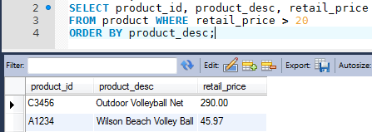

Where to Find Error Messages
If you type in SQL that has a syntax error and try to run it, you will see an error message at the bottom of the window, in the “output” area. In the example below, I misspelled the table name and you can see a very descriptive error message.
